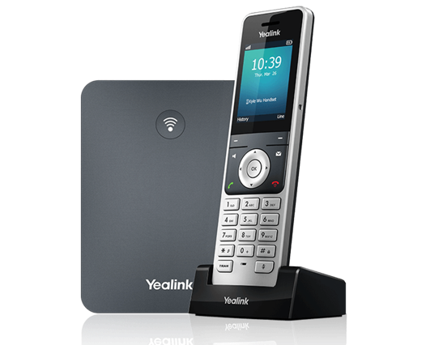 | Yealink® W76P DECT Phone  The Yealink® W76P DECT system is a 10-line, 10-handset wireless DECT phone solution packed with many advanced features that will enhance your day-to-day business activities and make your life easier. This guide is designed to help you use some of the most popular features with your new Yealink® W76P DECT system and handsets.

Turning Handset On/Off  To turn the handset on or off, long press (about two seconds) the end call key (red phone icon).  Navigation Keys  The navigation keys allow you to scroll through the options and lists on the display by pressing the left, right, up or down arrows. These keys are also pre-programmed with shortcuts to specific functions like ringtone volume and directories. Press the center OK key to bring up the phone menu and then use the navigation keys to go through the menu items. Press the end call key to back up through the menu selections to the default screen.  Soft Keys  The two soft keys located below the screen perform the functions that appear above the key. Their functions are context sensitive, which means the function of the soft keys change depending upon your current activity. For example, when on a call, the Options soft key will bring up a menu of in-call functions.  Answer a Call  To answer a call, press the call key (green phone icon).  Place a Call  To place a call, enter a number and press the call key. To redial a recently called number, press the call key first, then choose a number from the list. Calls can also be placed by choosing a number from History or the Directory. |  | Feature Codes  *72 Call Forwarding Always Activation  *73 Call Forwarding Always Deactivation  *90 Call Forwarding Busy Activation  *91 Call Forwarding Busy Deactivation  *92 Call Forwarding No Answer Activation  *93 Call Forwarding No Answer Deactivation  *44 Call Recording (if enabled)  *67 Calling Line ID Delivery Blocking per Call  *65 Calling Line ID Delivery per Call  *68 Call Park  *88 Call Park Retrieve  *98 Call Pickup  *11 Call Retrieve  *69 Call Return  *70 Cancel Call Waiting  *99 Clear Voice Message Waiting Indicator  *55 Direct Voicemail Transfer  *78 Do Not Disturb Activation  *79 Do Not Disturb Deactivation  *62 Voice Portal Access  *66 Last Number Redial  Note: Some of these codes may not be available to all users. See your group admin to add features.

Other Features  Set up Voicemail (first time)  - Dial *62 or your extension and place a call.  - At the prompt, enter in a unique passcode, then press #.  - Re-enter your passcode, then press #.  - Follow instructions to record your name.  - Follow prompts to:  - Access voice mailbox  - Access greetings menu  - Change passcode  - Exit voice portal  Retrieve Voicemail Messages  A blinking red “message waiting” indicator light at the top of each handset notifies you when you have a new voicemail message. A voicemail icon at the top of the display indicates you have new voicemails you have not listened to.  - To check your voicemail, press the Messages key.  - Select your extension and press the Select soft key or press the OK navigation key.  - A call will be placed to the voicemail service. Do the following:  - Enter your voicemail passcode if prompted, then press #. (If you forgot your passcode, please contact your system administrator.)  - Follow the audio prompts.  Hold and Resume a Call  - To hold, while on a call, press the Options soft key and then choose Hold from the menu.  - To resume, touch the Resume soft key.  Access Call Lists  - Call History can be accessed via the History soft key or press the OK key to bring up the menu and navigate to History.  - The default view is All Calls, Press the left/right navigation keys to cycle through the filters.  - To call an entry, highlight the one you want and press the call key.  - To access the Directory, press the down arrow or press OK to bring up the menu and navigate to Directory.  - Select Network Directory to access the PBX directory.  - Find the entry you want to call and press the call key. | Do Not Disturb  - To enable Do Not Disturb, press the OK key to bring up the menu, then select Call Features.  - Scroll to Do Not Disturb, press OK and then use the left/right keys to change the status to Enabled.  - Press the Save soft key to enable DND.  - A DND icon will indicate your handset is in DND.  - To turn off Do Not Disturb, repeat the process and Save the status as Disabled.  Make a Three-way Call  After the first call is connected:  - Press the Options soft key, then choose Conference from the list. The active call will be placed on hold.  - Dial the new party or choose any other handset and press the Conf. soft key.  - When the call connects, press the Conf. soft key again to join the calls.  Transfer a Call  After the first call is connected:  - Press the Options soft key, then choose Transfer from the list. The active call will be placed on hold.  - To transfer the call unannounced, enter the number or extension or choose any other handset from the list and press the Transfer soft key.  - To speak to the transfer-to party first, enter their number or extension or choose any other handset from the list and press OK in the navigation keys to initiate the second call.  - When the other party answers, announce the transfer. Then press the Transfer soft key again to complete the Transfer.  To transfer the call directly to another user’s voicemail  - During the transfer process, enter *55+extension and press Transfer.  - For example, enter *551001 to transfer the call directly to the voicemail box of extension 1001.

Call Forwarding
- Press the OK navigation key to bring up the menu and navigate to Call Features.
- Choose Call Forward and press OK.
- Choose either Always, Busy or No Answer.
- Use the right/left arrow keys to enable or disable this feature.
- When enabling a call forward option, a Target row will appear.
- Scroll down to select this row. Enter the number or extension to forward the call to.
- Press Save to enable the call forward option.
- When a call forward option is enabled, a red arrow icon shows at the top of the main display.
- To disable, follow the same steps and set the call forward option to Disabled, then press the Save soft key.
Shortcuts
- Pick up handset and dial:
  - *72 = Call Forwarding Always
  - *90 = Call Forwarding Busy
  - *92 = Call Forwarding No Answer
  - Enter destination number, then press #.
- To deactivate, dial:
  - *73 = Call Forwarding Always
  - *91 = Call Forwarding Busy
  - *93 = Call Forwarding No Answer

View a complete user guide at
https://support.yealink.com

