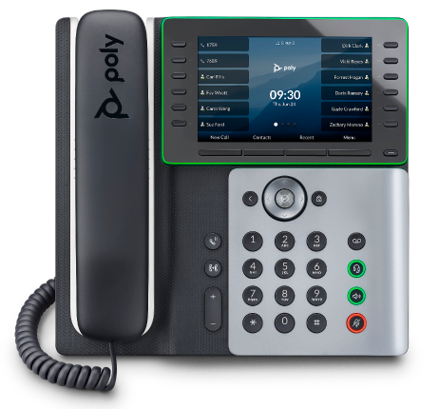 | HP-Poly® Edge E 500 Series Business Media Phone  Welcome to Replace Title  Replace Title is packed with many advanced features that will enhance your day-to-day business activities and make your life easier. This guide is designed to help you use some of the most popular features with your new HP-Poly® Edge E 500/550 phone —right out of the box.

Soft Keys  The soft keys located underneath the phone screen perform the functions that appear directly above them on the display. Their functions are context sensitive, which means the function of the soft keys changes depending upon your current activity. For example, if you are conferencing, the soft keys display functions related to the conference function.  Line Keys  With the Edge E500 series, you can access up to 12 physical line keys and up to 32 additional virtual keys. The line keys, located to the left of the phone screen, indicate the status of your lines and associated activity. The icon informs you when a line is idle, ringing, in use, on hold or disconnected altogether. Use the Pagination key to change virtual pages of line keys.  Navigation Keys  The Navigation keys allow you to scroll through the options and lists on the display keys by pressing left, right, up or down. To select an item, press the Select button (the button in the center of the navigation keys).  Answer a Call  To answer a call, simply pick up the handset or press the Answer soft key, Speakerphone key or Headset key.  Place a Call  To place a call, simply pick up the handset or press the New Call soft key, Speakerphone key or Headset key. Then dial the number. |  | Feature Codes  *72 Call Forwarding Always Activation  *73 Call Forwarding Always Deactivation  *90 Call Forwarding Busy Activation  *91 Call Forwarding Busy Deactivation  *92 Call Forwarding No Answer Activation  *93 Call Forwarding No Answer Deactivation *44 Call Recording (if enabled)  *67 Calling Line ID Delivery Blocking per Call *65 Calling Line ID Delivery per Call  *68 Call Park  *88 Call Park Retrieve  *98 Call Pickup  *11 Call Pull  *69 Call Return  *70 Cancel Call Waiting  *99 Clear Voice Message Waiting Indicator  *55 Direct Voicemail Transfer  *78 Do Not Disturb Activation  *79 Do Not Disturb Deactivation  *62 Voice Portal Access  *66 Last Number Redial  Note: Some of these codes may not be available to all users. See your group admin to add features.

Other Features  Set up Voicemail  - Either press the Messages key or initiate a call.  - If calling, dial *62 or your dial your extension.  - At the prompt, enter in a passcode, then press #.  - Re-enter your passcode, then press #.  - Follow instructions to record your name.  - Follow prompts to:  - Access voice mailbox  - Access greetings menu  - Change passcode  - Exit voice portal  Retrieve Voicemail Messages  A flashing red light bar below the display notifies you when you have a new voicemail message.  - To check your voicemail, press the Messages key, or initiate a call and dial *62 or your dial your extension.  - Enter your voicemail passcode if prompted, then press #. (If you forgot your passcode, please contact your system administrator.)  - Follow the audio prompts.  Hold and Resume a Call  - To hold, press the Hold hard or soft key.  - To resume, press the Resume hard or soft key.  Access Call Lists  - Call History can be accessed using the Navigation keys or by pressing Home and selecting Recent Calls.  - To see received calls, press the left navigation button. To see placed calls, press the right navigation button. To see missed calls, press the down navigation button.  - To dial a number, scroll to the desired number, then press the Dial soft key or the Select button.  Do Not Disturb  - To enable Do Not Disturb, press the DND soft key.  - To disable, press the DND soft key again. | Make a Three-way Call  After the first call is connected:  - Press the More soft key, then the Confrnc soft key. The active call will be placed on hold.  - Dial the new party.  - When the call connects, press the Confrnc soft key again to join the calls.  Transfer a Call  - After the first call is connected:  - Press the Transfer hard key or soft key. (The active call will be placed on hold.)  - To speak to the transfer-to party first, Dial the number or extension and press Send.  - When the party answers, announce transfer. Then press Transfer again to complete.  - To transfer the call unannounced, press the Blind Transfer soft key first, then Dial the number or extension and press Send. The transfer will complete.  To transfer the call directly to another user’s voicemail  - During the transfer process, Dial *55 instead of the extension  - Dial the extension, followed by #.  - A confirmation will announce the transfer is complete.  Call Forwarding  - Press the Forward soft key or the Home key.  - If using Home, press the down arrow on the Navigation keys until the Forward Menu option is selected. Press the Select navigation button.  - Use the up and down arrows on the Navigation keys to select your option.  - Call Forwarding Always  - Call Forwarding No Answer  - Call Forwarding Busy  - Enter destination number and press Enable soft key.  - To disable, follow the same steps and press Disable.  Shortcuts  - Pick up handset and dial:  - *72 = Call Forwarding Always  - *90 = Call Forwarding Busy  - *92 = Call Forwarding No Answer  - Enter destination number, then press #.  - To deactivate, dial:  - *73 = Call Forwarding Always  - *91 = Call Forwarding Busy  - *93 = Call Forwarding No Answer
  View a complete user guide at
  https://support.hp.com/us-en/poly/products/phones/phones-desk

